SYNOPSIS

ON

**ONLINE PIZZA DELIVERY SYSTEM**

SUBMITTED IN PARTIAL FULFILLMENT OF THE REQUIREMENTS

FOR THE DEGREE OF

**BACHELORS OF COMPUTER APPLICATION**

SESSION

2016-2019



JAMIA HAMDARD UNIVERSITY

SCHOOL OF OPEN AND DISTANCE LEARNING

HAMDARD NAGAR, NEW DELHI-110062

SUBMITTED BY: BAZILA KHAN

ENROLLMENT NO : ODL/16/401/0073 SUBMITTED TO :

SYNOPSIS

ON

**ONLINE PIZZA DELIVERY SYSTEM**

SUBMITTED IN PARTIAL FULFILLMENT OF THE REQUIREMENTS

FOR THE DEGREE OF

**BACHELORS OF COMPUTER APPLICATION**

SESSION

2016-2019



JAMIA HAMDARD UNIVERSITY

SCHOOL OF OPEN AND DISTANCE LEARNING

HAMDARD NAGAR, NEW DELHI-110062

SUBMITTED BY: MOHAMMED OMER MAZHAR

ENROLLMENT NO : ODL/16/401/0104 SUBMITTED TO :

**CONTENTS**

|  |  |
| --- | --- |
| **S.NO** | **CHAPTER NAME** |
| 1. | Introduction |
| 2. | Objectives |
| 3. | Requirement Specification |
| 4. | Data Flow Diagram |
| 5. | Conclusion |

**INTRODUCTION**

The "ONLINE PIZZA DLIVERY SYSTEM" has been developed to override the problems prevailing inthe practicing manual system. This software is supported to eliminate and in somecases reduce the hardships faced by this existing system. Moreover this system isdesigned for the particular need of the company to carry out operations in a smooth andeffective manner.

The application is reduced as much as possible to avoid errors while entering the data. It also provides error message while entering invalid data. No formal knowledge isneeded for the user to use this system. Thus by this all it proves it is user-friendly. Online pizza delivery system, as described above. can lead to error free, secure, reliable and fast

management system. It can assist the user to concentrate on their other activities ratherto concentrate on the record keeping. Thus it will help organization in better utilization ofresources.

Every organization, whether big or small has challenges to overcome and managingthe information of Online Order. Pizza, Order Status, Payments. Coupons. Every online pizza delivery has different Pizza needs, therefore we design exclusive employeemanagement systems that are adaptedto your managerial requirements. This isdesigned to assist in strategic planning, and will help you ensure that yourorganize equipped with the right level of information and details for your future goals.

Those busy executive who are always on the go, our systems come with remote accessfeatures which will allow you to manage your workforce anytime, at all times. Thesesystems will ultimately allow you to better manage resources.

**OBJECTIVE**

The main objective of the online pizza delivery system is to manage the details of payments, customers, coupons, pizza, order status. It manage all the information about payments, online order, order status, payments. The project is totally built at administrative end and thus only the administrator is guarantees the access. The purpose of the project is to build an application program to reduce the manual work for managing the payments, customer, online order, coupons, pizza, order status.

**FUNCTIONALITIES PROVIDED BY ONLINE PIZZA DELIVERY SYSTEM ARE AS FOLLOWS:**

1. It tracks all the information of online order, payments details online for order status details, coupons details, pizza.
2. Manage the information of online order.
3. Shows the information and description of the pizza, customer.
4. Manage the information of the pizza
5. Editing, adding and updating of records is improved which results in proper resource management of pizza data.

**REQUIREMENT SPECIFICATION**

The software requirements specification is produced at the culmination of the analysis task. The function and performance allocated to software as part of system engineering are refined by establishing a complete information description, a detailed functional, and behavioral description, an indication of performance requirements and design constraints, appropriate validation criteria, and other data pertinent to requirements.

**The proposed system has the following requirements:**

1. System needs store information about new entry of pizza.
2. System needs to help the internal staff to keep information of online order and find them as per various queries.
3. System needs to maintain quantity record.
4. System need to delete and update the record.
5. System also needs a search area.
6. It also needs a security system to prevent data.

**DATA FLOW DIAGRAM**

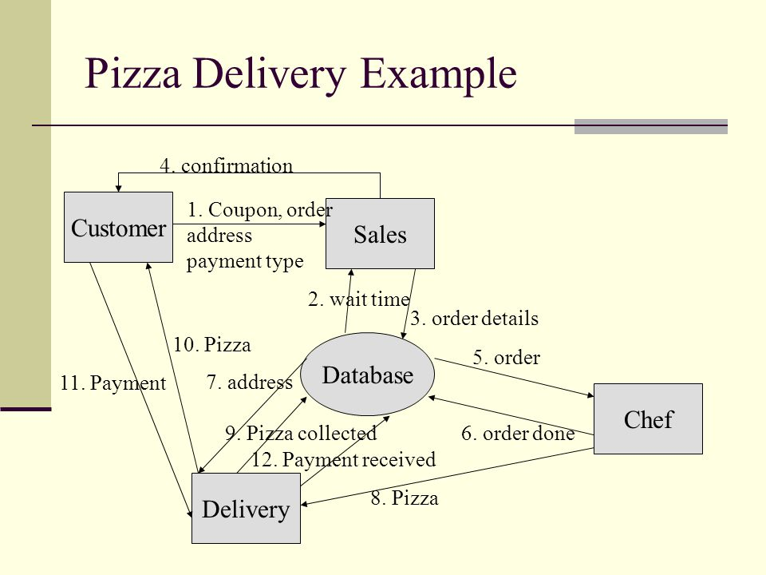

**CONCLUSION**

The aim of proposed is to develop a system of improved facilities. The proposed system can overcome all the limitations of the existing system. The system provides proper security and reduces the manual work.

1. Security of data.
2. Ensure data accuracies.
3. Proper control of the higher officials.
4. Minimize manual data entry.
5. Minimum time needed for the various processing.
6. Greater efficiency
7. Better service.
8. User friendliness and interactive.
9. Minimum time required.